Digital Pharmacy

Authors:

Nico Heiniger

Gabriel Massaro

Rinson Mankudiyil

Hsaine El-Ali

**Introduction:**

In 2020 the COVID pandemic took everyone by surprise forcing countries to close their borders and instore new restrictions and policies. Business had to adapt by quickly finding ways to work remotely due to lockdowns. The pandemic has really affected everybody especially the elderly and people in the risk category.

How would the people with chronical illnesses, who are now at risk each time they venture outside get their medication?

The Digital Pharmacy is a project aiming to provide a general solution to small and medium size pharmacies in implementing online purchasing. Buy enabling customers to purchase their prescription based and over their counter medication safely from home. This would help removing risks associated with COVID. In addition, it would allow pharmacies to expand their customer base.

**Project Description:**

This project aims to showcase how an online shopping solution could be implemented for digital pharmacies.

*The Web page*

The first thing is to create an interface for customers to interact with. It is easiest done via a Webpage or an application. In our project we decided to create a Webpage. The customer will be able to open it via the browser, select the desired medications and input all the information necessary.

Using HTML, React JS with some styling from Bootstrap CSS we created a simple Demo version of the Digital Pharmacy.

The main function of the web page is to select the drugs and collect data, such as email address, …..) necessary to complete the whole process. All information about the drugs is contained in a data table implemented with AirTables. The AirTable is linked to the web page and acts as a back-end data base.

This way it is easy for any employee to add or remove a certain drug. In addition, it allows to specify which drug is sellable over the counter and which ones need a prescription from a doctor.

After selecting the desired medications some personal information will required in order to complete the order.

*Camunda*

The whole business process was described using BPML in Camunda modeler. The customer will start the process by completing an order on the web page as shown in the previous section.

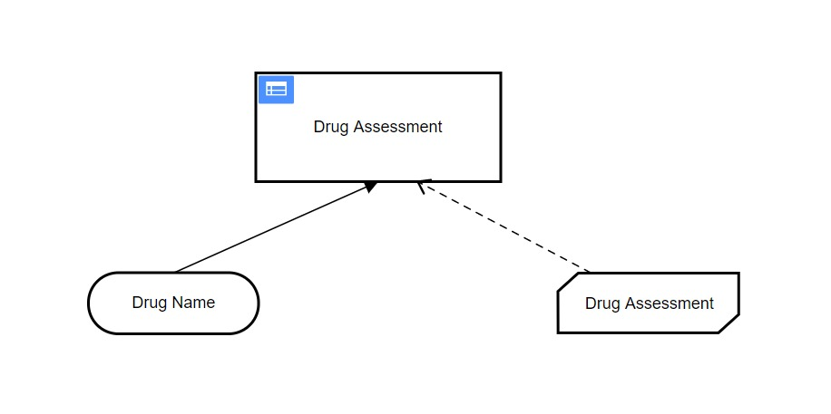Next, the order will be received by an employee of the pharmacy. At this stage it is important to know if the medication is prescription based or over the counter. For this during the next step (drug assessment) a DMN table has been implemented, in which all the drugs are annotated as prescription or over the counter. This way the process can decide which way it will follow.

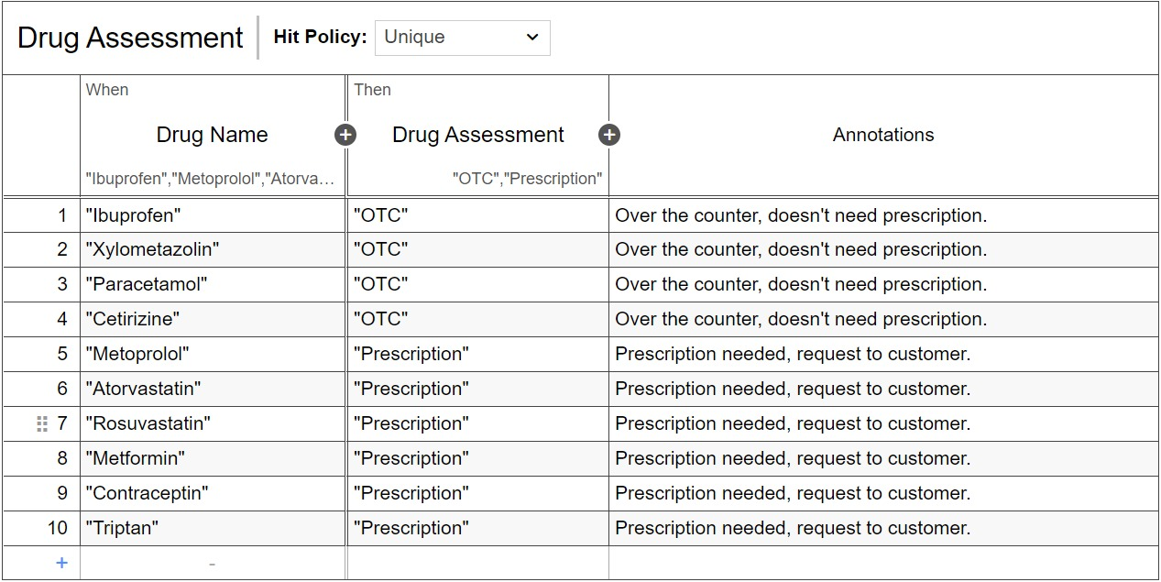

If the drug is prescription based, then the process will follow the upper path and the next step will request the customer to provide a prescription. (See next section).

If the medication is over the counter, then the order will move forward without requesting any additional documents.

*Integromat*

As mentioned previously, if the drug needs a prescription, then an email must be sent to the customer requesting to provide it in PDF format. For this purpose, we have decided to use Integromat. This platform allows us to generate an email that will be sent to the address provided by the customer.

Integromat serves another important purpose. It periodically scans the mailbox of the digital pharmacy for any new emails containing PDF documents. It then stores them on Google drive and saves in Google Sheets the Name, Date, Medicine and Email. When the information is received then it sends the notification to Camunda.

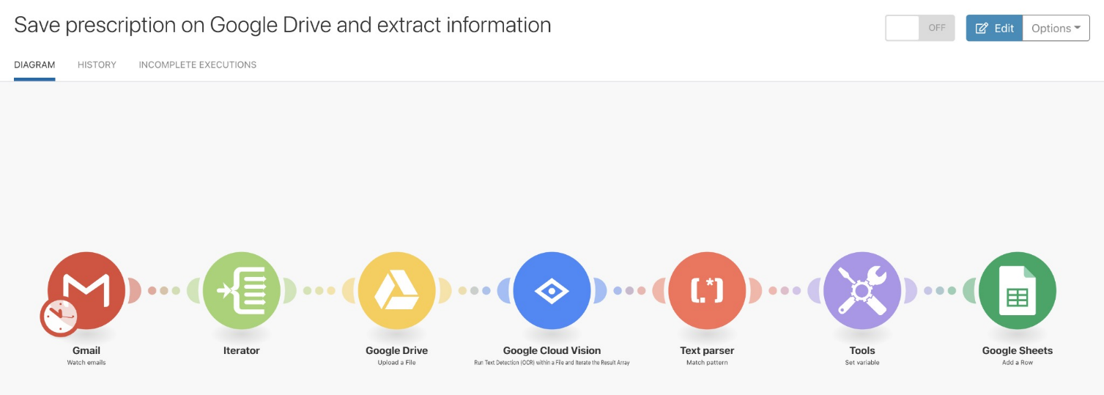

When the customer has provided the prescription Camunda will receive a request to be manually validated by an employee.

*Lager*

After the reception of the prescription, and manual confirmation, the process will be transfer to the Lager. The employee at the station will be requested to manually pack the order displayed to him and to confirm it’s readiness.

When confirmed the process will ones again redirect to Intregromat to updates the stock in the AirTables.

*Billing*

The final step of the process is to send the final confirmation the the customer that includes the bill. This step is done via Integromat, which sends an email to the provided by the customer email address.

*Step by Step*

1. The customer oders medication using the Web Page:
   1. Web page is created Using HTML, React JS
   2. with some styling from Bootstrap CSS.
   3. The information regarding all the drugs available for order is stored in a data table and implemented using AirTables

During the order, the customer will provide his email and …().

1. The order is received by the pharmacy and the process is started.
   1. The order is received by an employee of the pharmacy
   2. Depending on the type of drug (prescription or OTC) different routes will be used. This decision is taken referring to a DMN table created with Camunda.
   3. If the drug needs a prescription, then it will request it from the customer in PDF format, by sending a request to the provided email address. This step is implemented using Integromat.
2. The customer replies to the email attaching his prescription in PDF format.
   1. Integromat recognises the incoming email.
   2. Saves the PDF file in Google drive.
   3. Saves essential data in Google Sheets
3. When this step is successfully completed it notifies Camunda that the process can proceed by requesting an employee of the pharmacy to confirm it manually. The manual request is a check box created using Camunda forms.
4. The next step will be executed in the Storage or lager section of the pharmacy. An employee will have to manually pack the order and confirm when it’s ready.
5. When the order is ready a notification will be sent to Integromat to update the inventory by decreasing the stock by one in the AirTables.
6. Finally, the final step is to notify the customer that his order is sent and provide him with an invoice. The email is automatically sent with Integromat